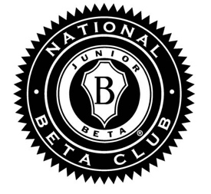
Latin College Prep Charter
National Junior Beta Club Officers

There are seven officer positions in our chapter of the Junior Beta Club: President, Vice President, Secretary, Treasurer, Historian, and Grade Level Representatives (one for each grade level)
President: The president will be responsible for conducting monthly meetings and performing any other leadership responsibilities requested of him/her throughout the year by the Beta Sponsor and Principals. He/She will work with the Vice President to promote club service projects.
Vice President: The vice president will work to develop service projects of interest to the majority of members. The projects should be of value to the Beta Club membership or entire school or the community.
Secretary: The secretary should be detail-oriented and willing to keep excellent records of membership along with detailed notes from monthly meetings. These notes will be kept organized in a notebook and returned to the club advisor at the end of the year as a record of activities for the year. He/She will also take pictures for our notebook, our webpage and the National Beta organization. This person should also be willing to write thank-you notes to adults and organizations that assist the Beta Club during the term of office.
Treasurer: The treasurer will be responsible for reporting the balances in the club account periodically throughout the year. This person will also be responsible for collecting service project logs. He/She will tally the information to determine eligibility for club membership the following school year. The treasurer will also work closely with Mrs. Adwater and Mrs. Lambert (school accountant) by filling out paper work and turning over funds for any money raised by Junior Beta.
Chapter Historian: The chapter historian will be the main photographer of our chapter. He/She will be responsible for keeping our scrapbook organized and be the chairperson of the scrapbooking committee. He/She can appoint other chapter photographers with the approval of the sponsors.
Grade Level Representatives (2): This position requires someone who can help carry out any of the work necessary to keep the club running smoothly. You must be able to work well with all of the officers as you will be assisting them with any special projects or requests. You will also be responsible for disseminating information about Beta Club Events to your Beta Club grade Level members
All officers should be willing and able to occasionally meet before or after school to plan club activities in addition to our regularly scheduled meetings.

